SYSTEM REQUIREMENTS –21070006054_Arda_Harman

# **Requirements**

## **Functional Requirements**

* **User should be able to register**
* **User should be able to login**
* **User should be able to view and edit his/her profile**
* **User should be able to view, modify and cancel his/her appointments**
* **Patient should be able to make enquiry**
* **Patient should be able to make appointment**
* **Doctor should be able to add time slot**
* **Admin should be able to add and delete users**
* **Admin should be able to edit user information**
* **Admin should be able to reply enquiries**
* **Admin should be able to delete past appointments**

## **Non-functional Requirements (Don't forget to describe the types of non-functional requirements you've written.)**

* **Logging in should be done less than 0.07 ms (Performance)**
* **User’s data should be encrypted by MIS data protection process (Security)**
* **Users should understand how to use the system easily (Usability)**
* **System shouldn’t produce any software related errors (Reliability)**
* **System should support both web and mobile (Supportability)**

**6 sequence diagrams**

**#1 - Login**

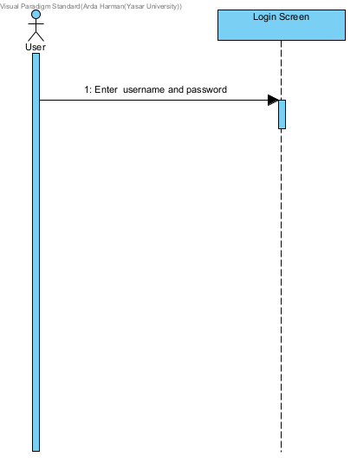

**#2 – Create Account**



**#3 - Edit User Info**

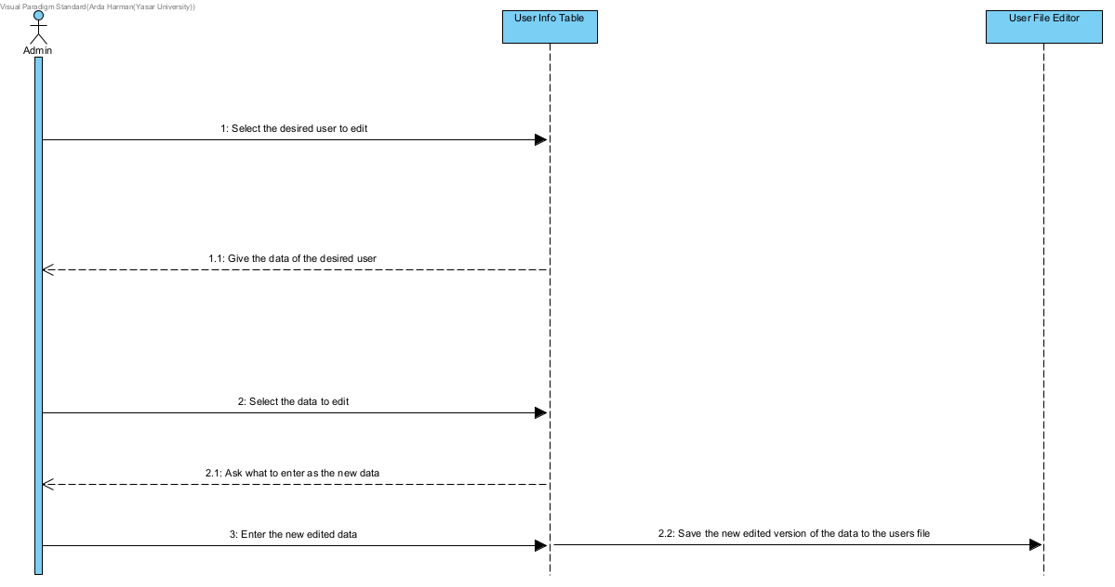

**#4 – Make Enquiry**

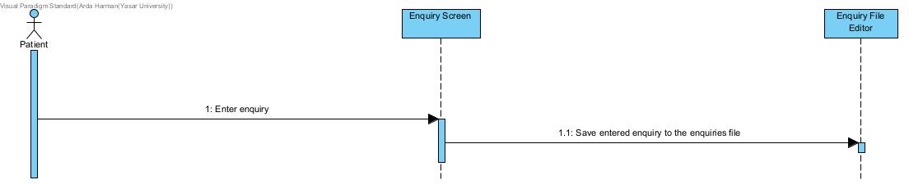

**#5 – Add Time Slot**

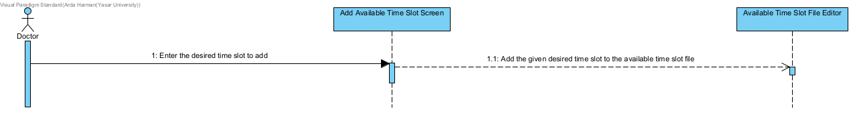

**#6 – Make Appointment**

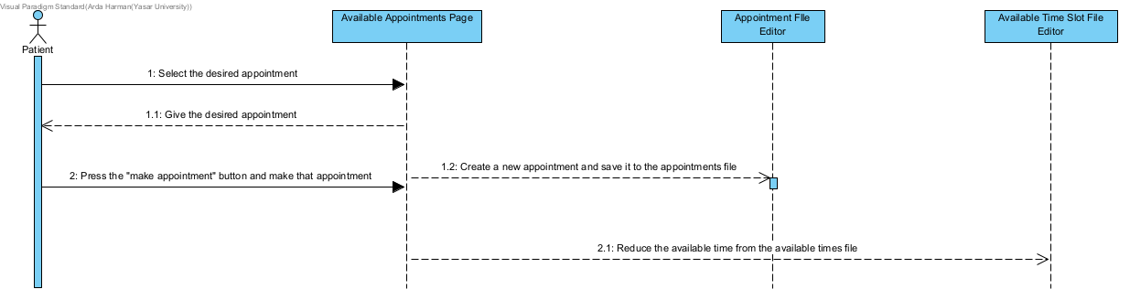

## **Use case Diagram**

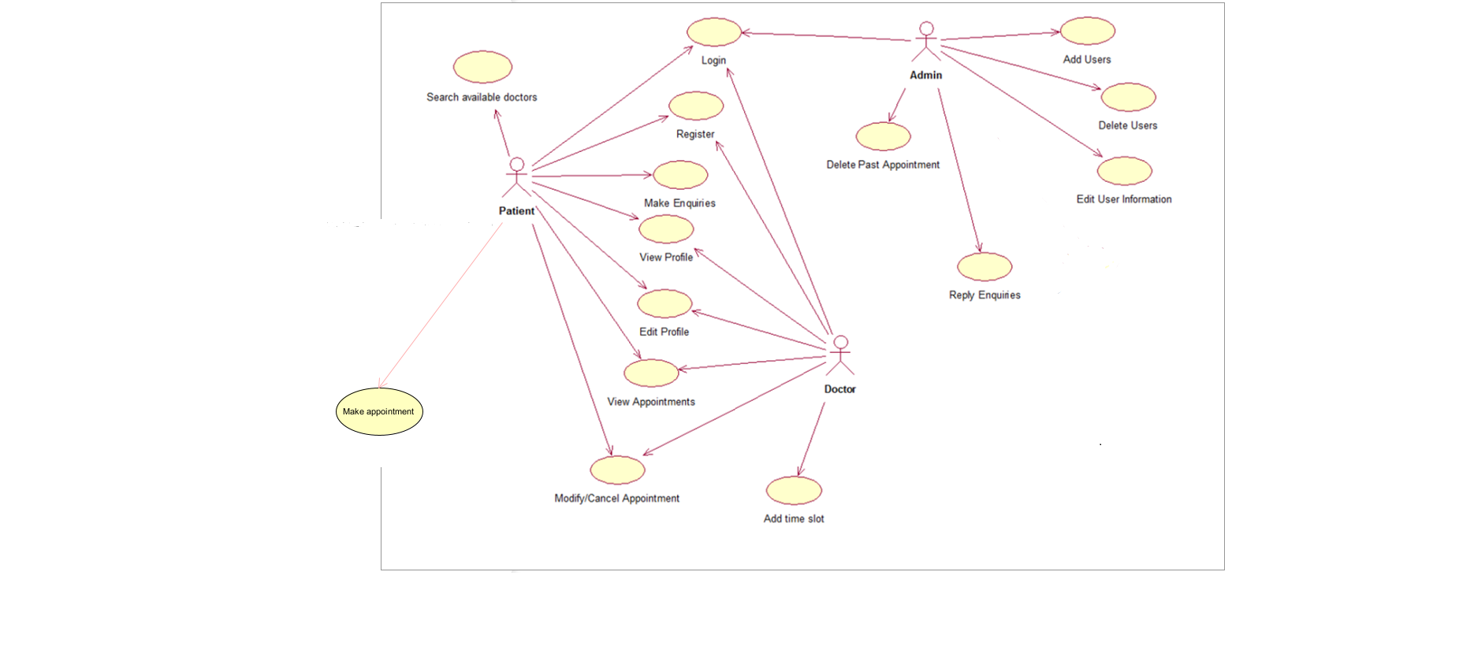

## **Use case Specification**

|  |  |  |
| --- | --- | --- |
| Use Case UC-1 | **Modify Info About Appointment** | |
| Related Requirements: | **Patient must have an appointment, an account and the system must be available** | |
| Initiating Actor: | **Patient** | |
| Actor’s Goal: | **Modify Info About Appointment** | |
| Participating Actors: | **Patient, Doctor** | |
| Preconditions: | * **Patient and Doctor must have an account at the system** * **Patient must have a made appointment to modify** * **System must be available and accesible** | |
| Postconditions: | * **Appointment is modified** * **New modified version of the appointment is saved to the “appointment.txt” file** | |
| Flow of Events for Main Success Scenario: | | | |
| **->** | **1.** | **Patient selects the appointment to modify** |
| **<-** | **2.** | **System asks what to replace the current data with** |
| **->** | **3.** | **Patient enters the new modified data** |
| **<-** | **4.** | **System modifies the data with the entered data** |
| Flow of Events for Extensions (Alternate Scenarios): | | | |
| **<-** | **3.1.** | **Patient enters an invalid data** |
| **->** | **4.** | **System gives error and does not accept the data** |

## **Screenshot of Test Use case**

1. **A) Before modification, “appointments.txt” file**

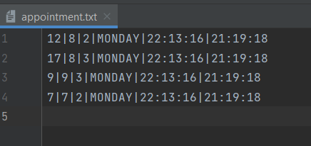

1. **B) fore modification, “view appointment” page (modify appointment Is done under this page)**

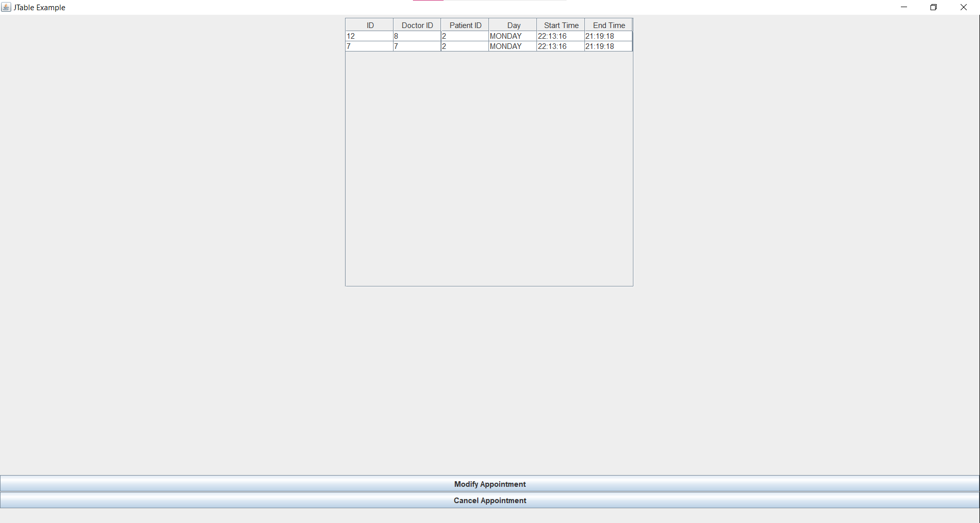

1. **Patient selects the appointment to modify**

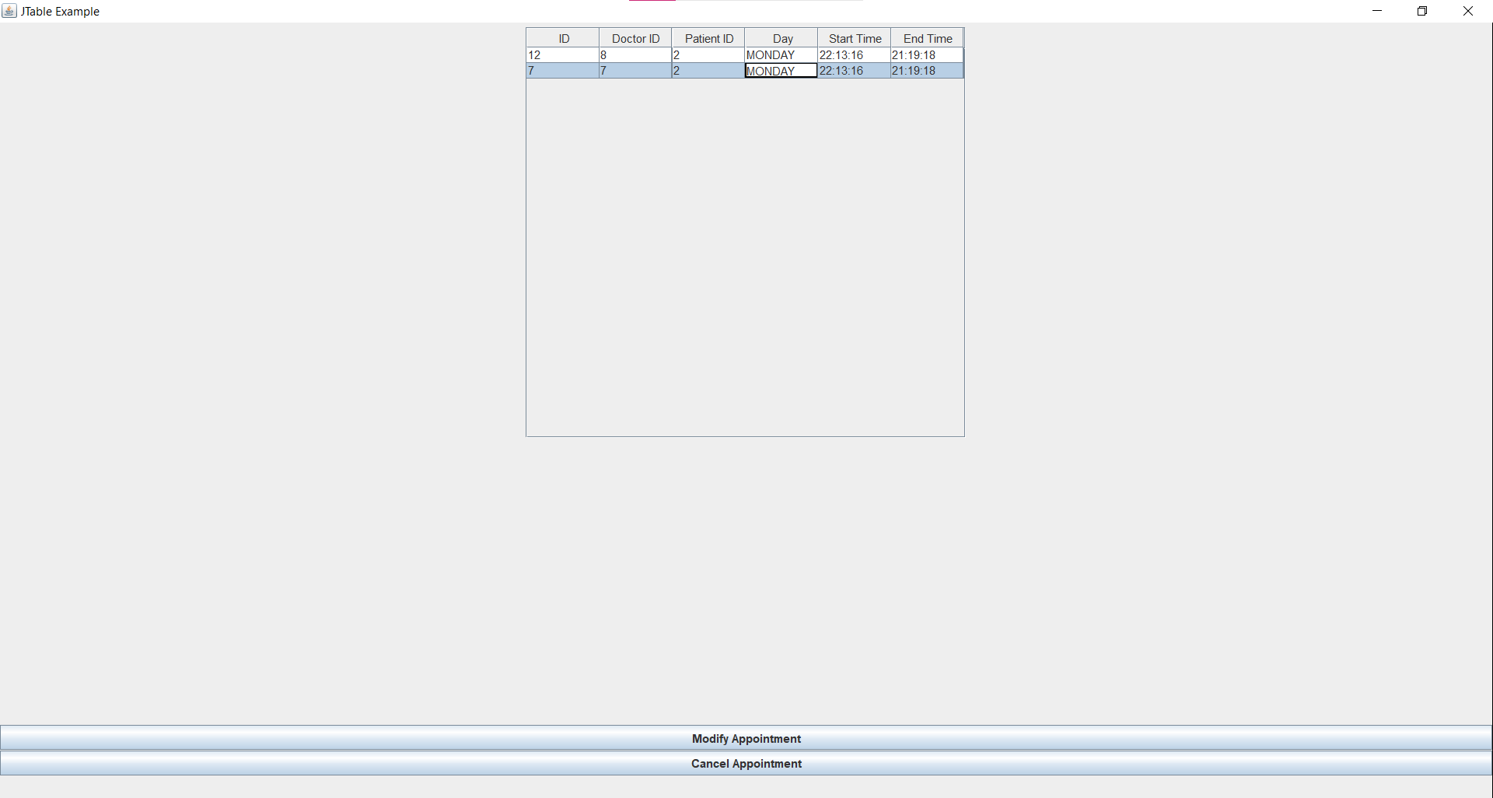

1. **System asks what to replace the current data with**

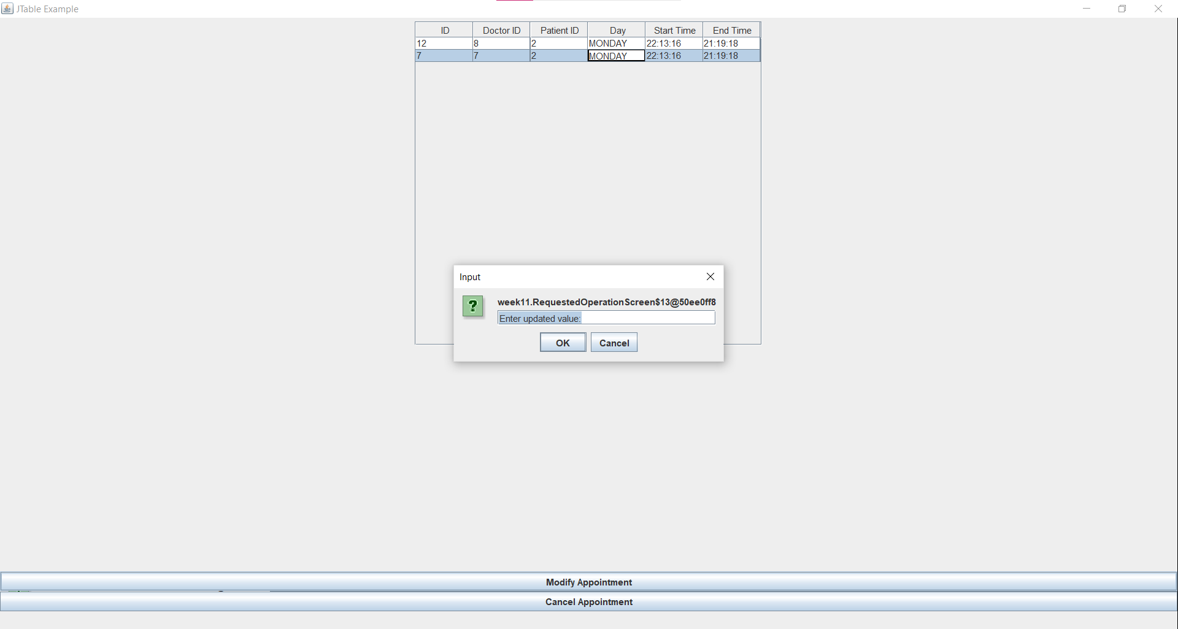

1. **Patient enters the new modified data**

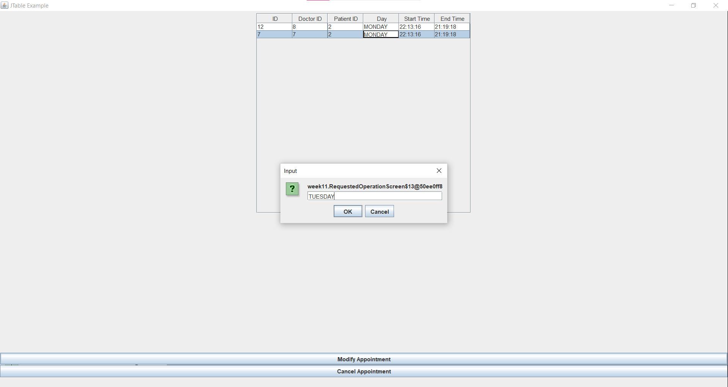

1. **A) System modifies the data with the entered data after modification**

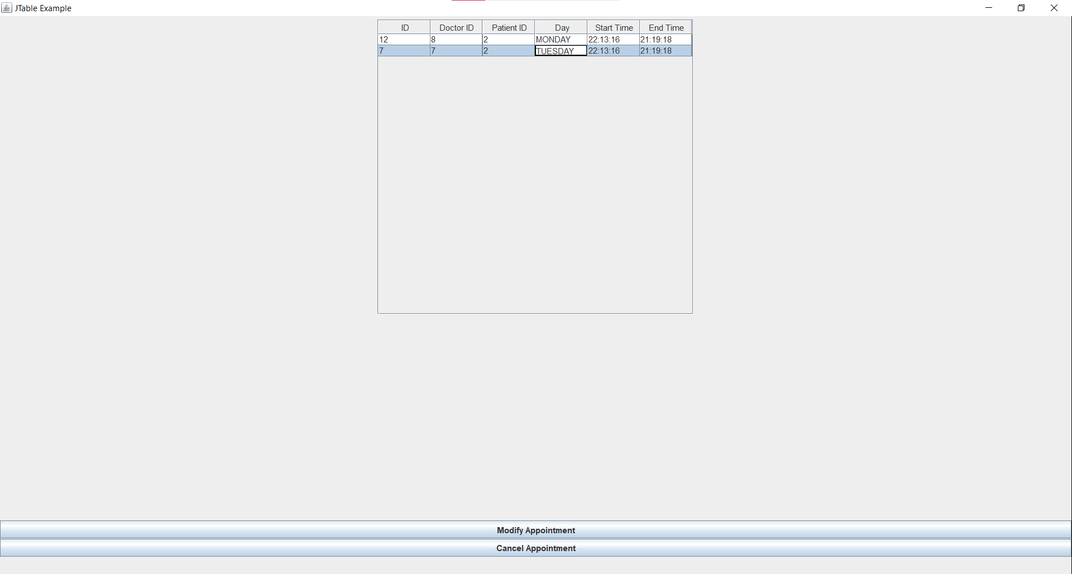

**B) Modified version of “appointment.txt file” after modification**

